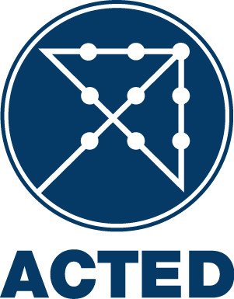
NATIONAL CALL FOR TENDER
Supply and installation of horizontal centrifugal water pump in Zummar,
Tel Afar district, Ninewa Governorate
T/10DVI/57F/RWI/ERB/WASH/22-09-2020/001

ACTED (Agency for Technical Cooperation and Development), implementing several projects in Iraq, and is inviting contractors to submit offers for the following lots:

Lot # | Description | Product category | Product stage | INCOTERM/Delivery Point and Deadline
1 | Supply and installation of horizontal centrifugal water pump in Zummar, Tel Afar district, Ninewa Governorate | Works/Engineering | Finished | DDP – Zummar ,Tel Afar district, Ninewa Governorate Ninewa Governorate  36.723048, 42.737384  15 days after contract signature

The tender will be conducted using ACTED standard bidding documents, open to all qualified suppliers and service providers. The Bidding Documents (in English) may be collected free of charge by all interested bidders from the NCCI website at https://ngotenders.net/ under the section “Tenders/Jobs”.

Or, if the situation allows it, at the following address:
ACTED representative office in Erbil: IRAQ (6th street (Khabat street) on the right after Ankawa intersection,1st street on the right, House #: 240/1/467 Hadiyab quarter, Ainkawa, Erbil, Iraq).

Potential bidders are encouraged to consult the NCCI website regularly for potential modification to the present tender and/or the bidding documents.
ACTED reserves the right to cancel the call for tender.

All bids must be submitted before 13/10/2020 (October 13th, 2020) at 04:00 PM (Iraq time) by E-mail at iraq.tender@acted.org, Cc tender@acted.org or at the address mentioned above in a sealed envelope. Late Bids will be automatically rejected.

ACTED will not be responsible for any costs or expenses incurred by the Bidders in connection with the preparation and submission of their bids to ACTED.

A tender opening session will take place on after the closing date of the tender. For any information regarding this presentation session, please send an e-mail to iraq.tender-questions@acted.org cc Iraq.tender@acted.org .

The presence of bidders’ representative is not allowed due to the current corona pandemic situation.

For all inquiries regarding this tender, please contact the ACTED representative office in Erbil, IRAQ not later than 07/10/2020 (October 07th, 2020) at 04:00 PM (Iraq time) in person or by E-mail at iraq.tender-questions@acted.org , Cc tender@acted.org.

Note: if you witness or suspect any unlawful, improper or unethical act or business practices (such as soliciting, accepting or attempting to provide or accept any kickback) during the tendering process, please send an e-mail to transparency@acted.org.

